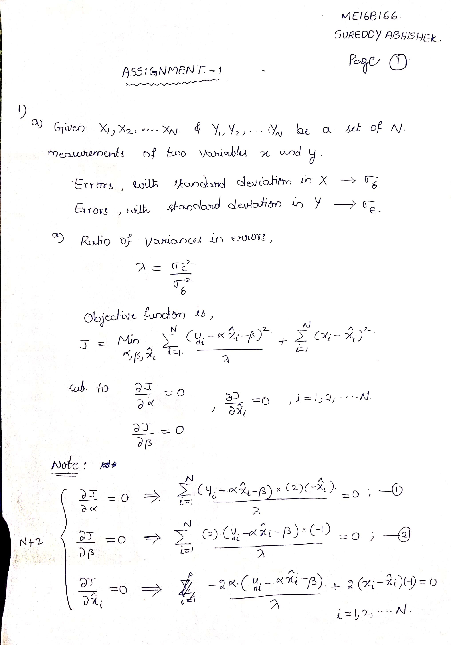

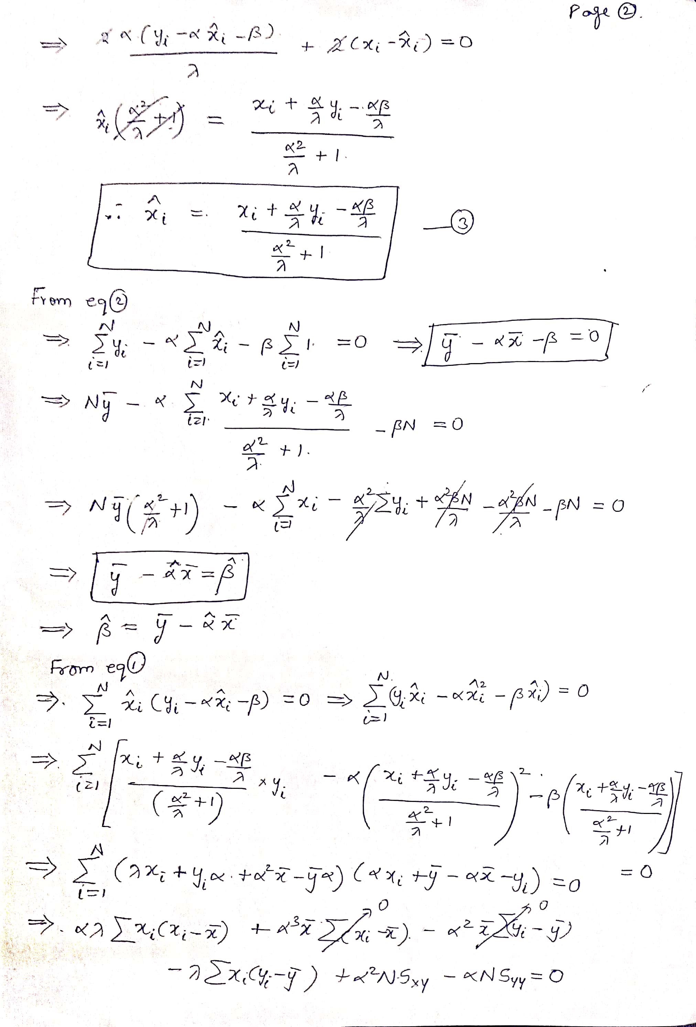

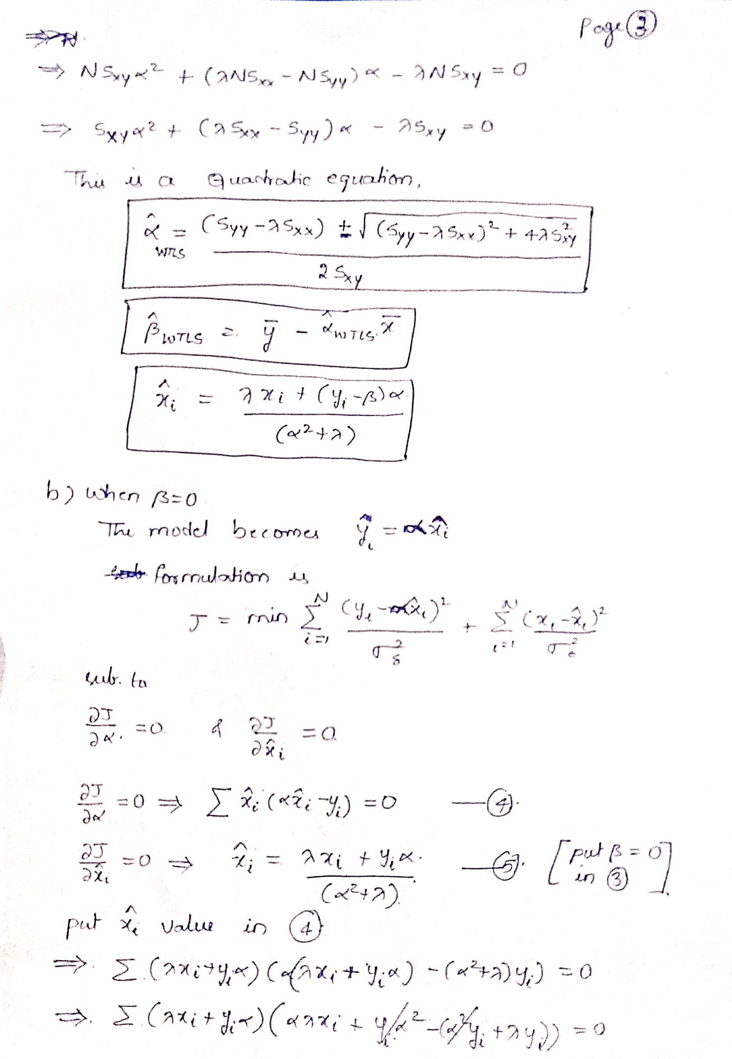

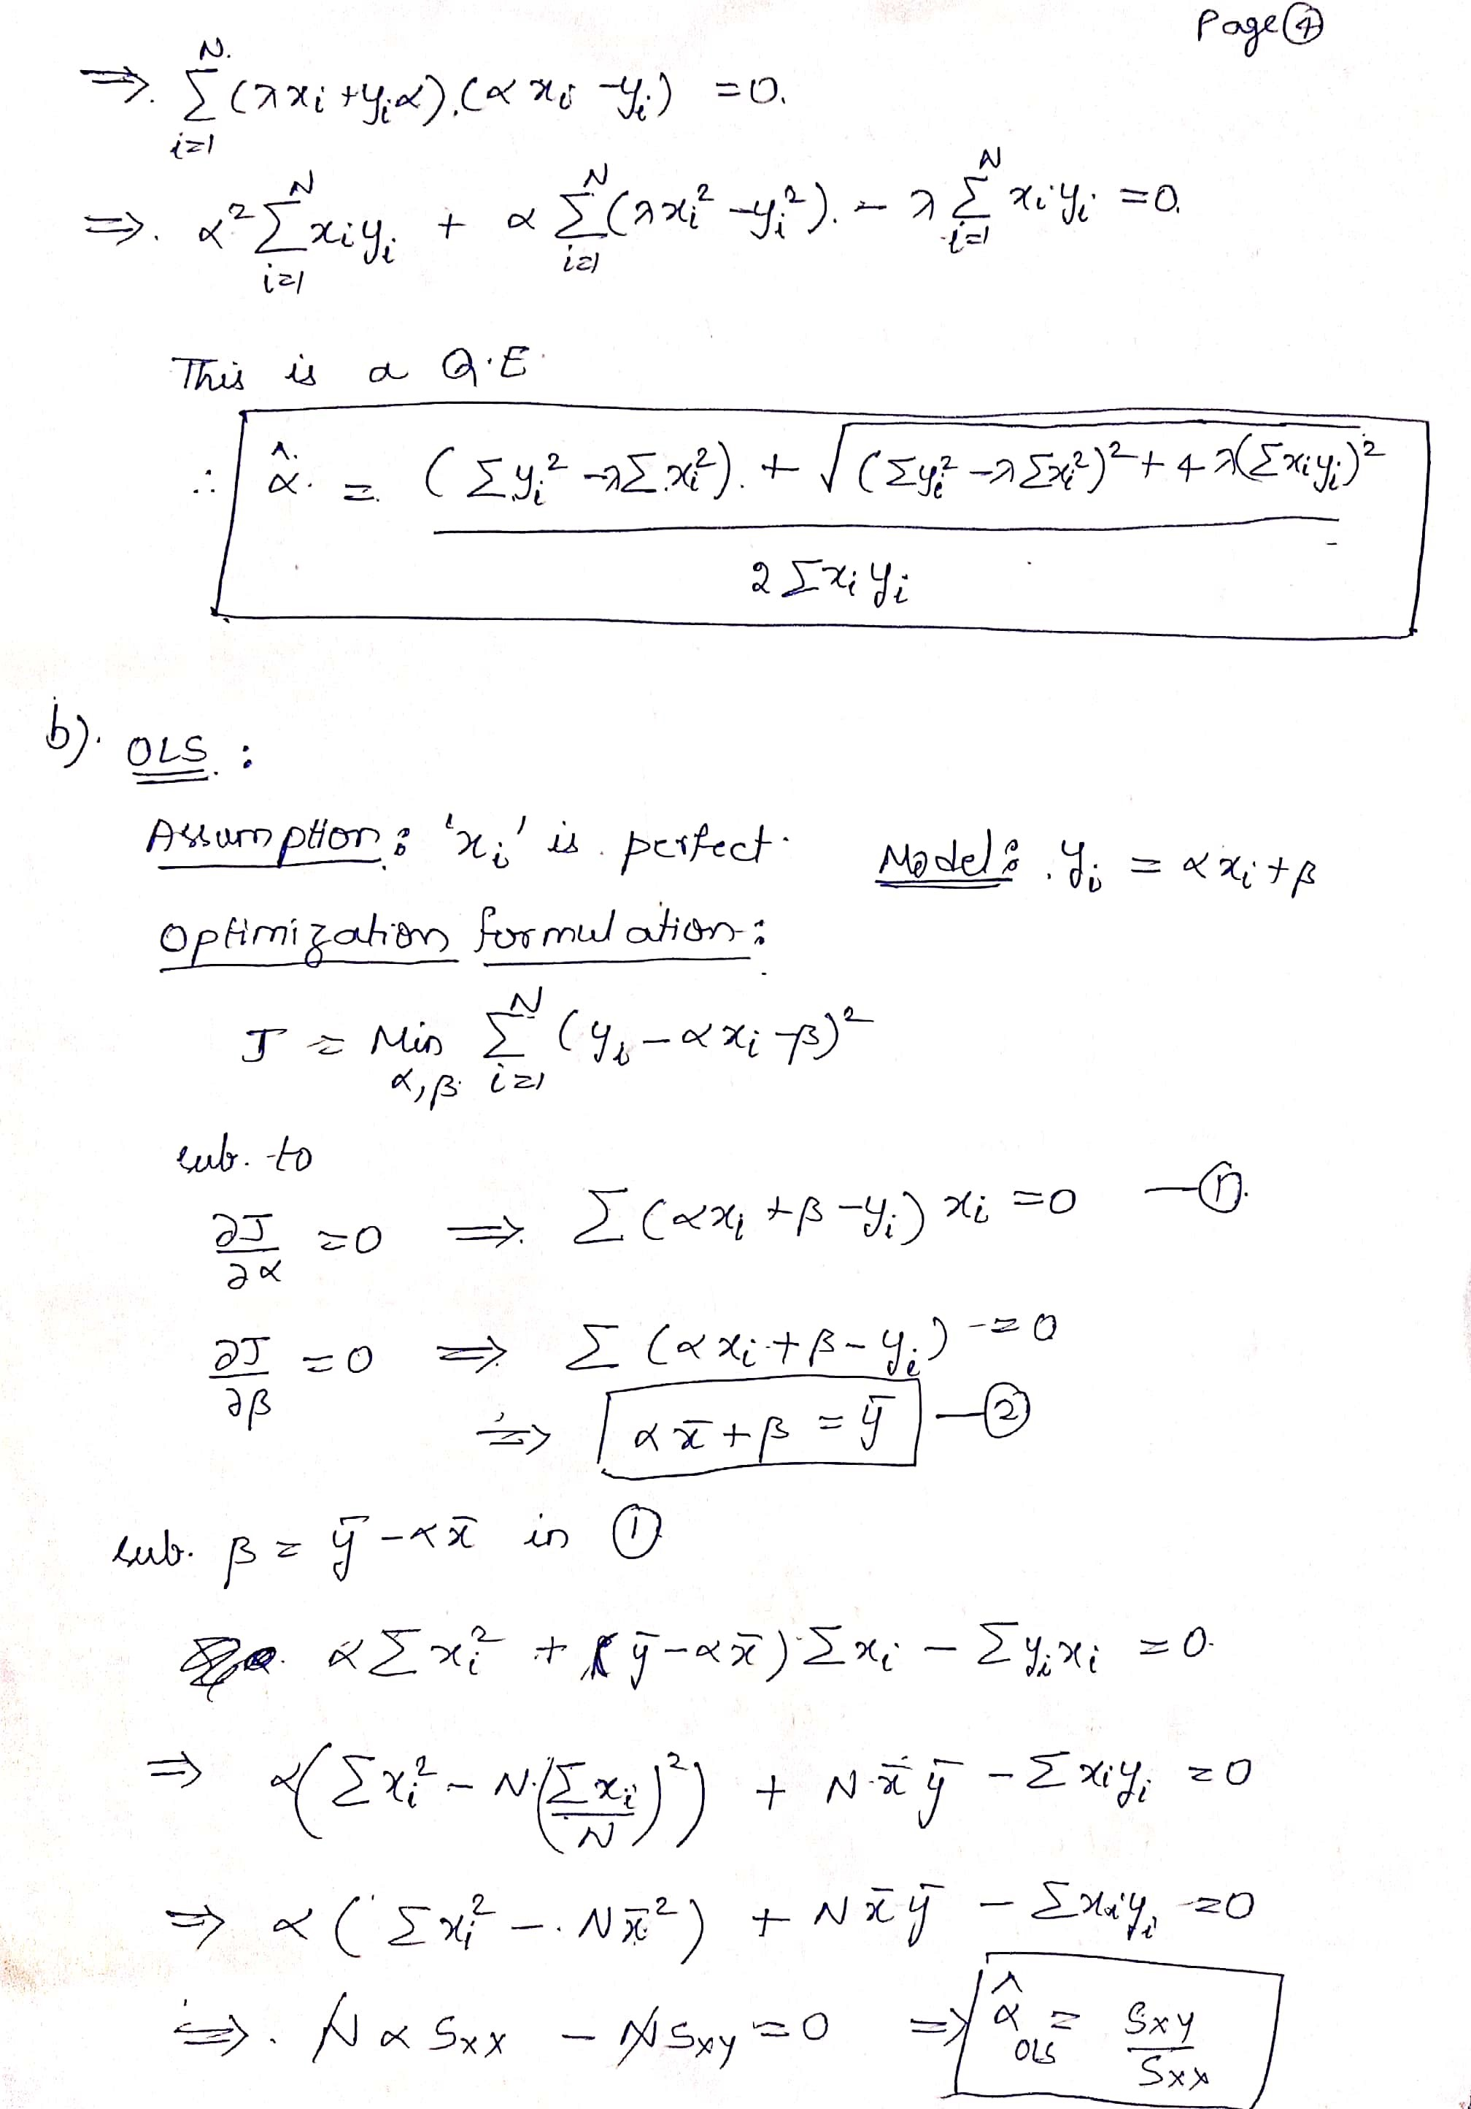

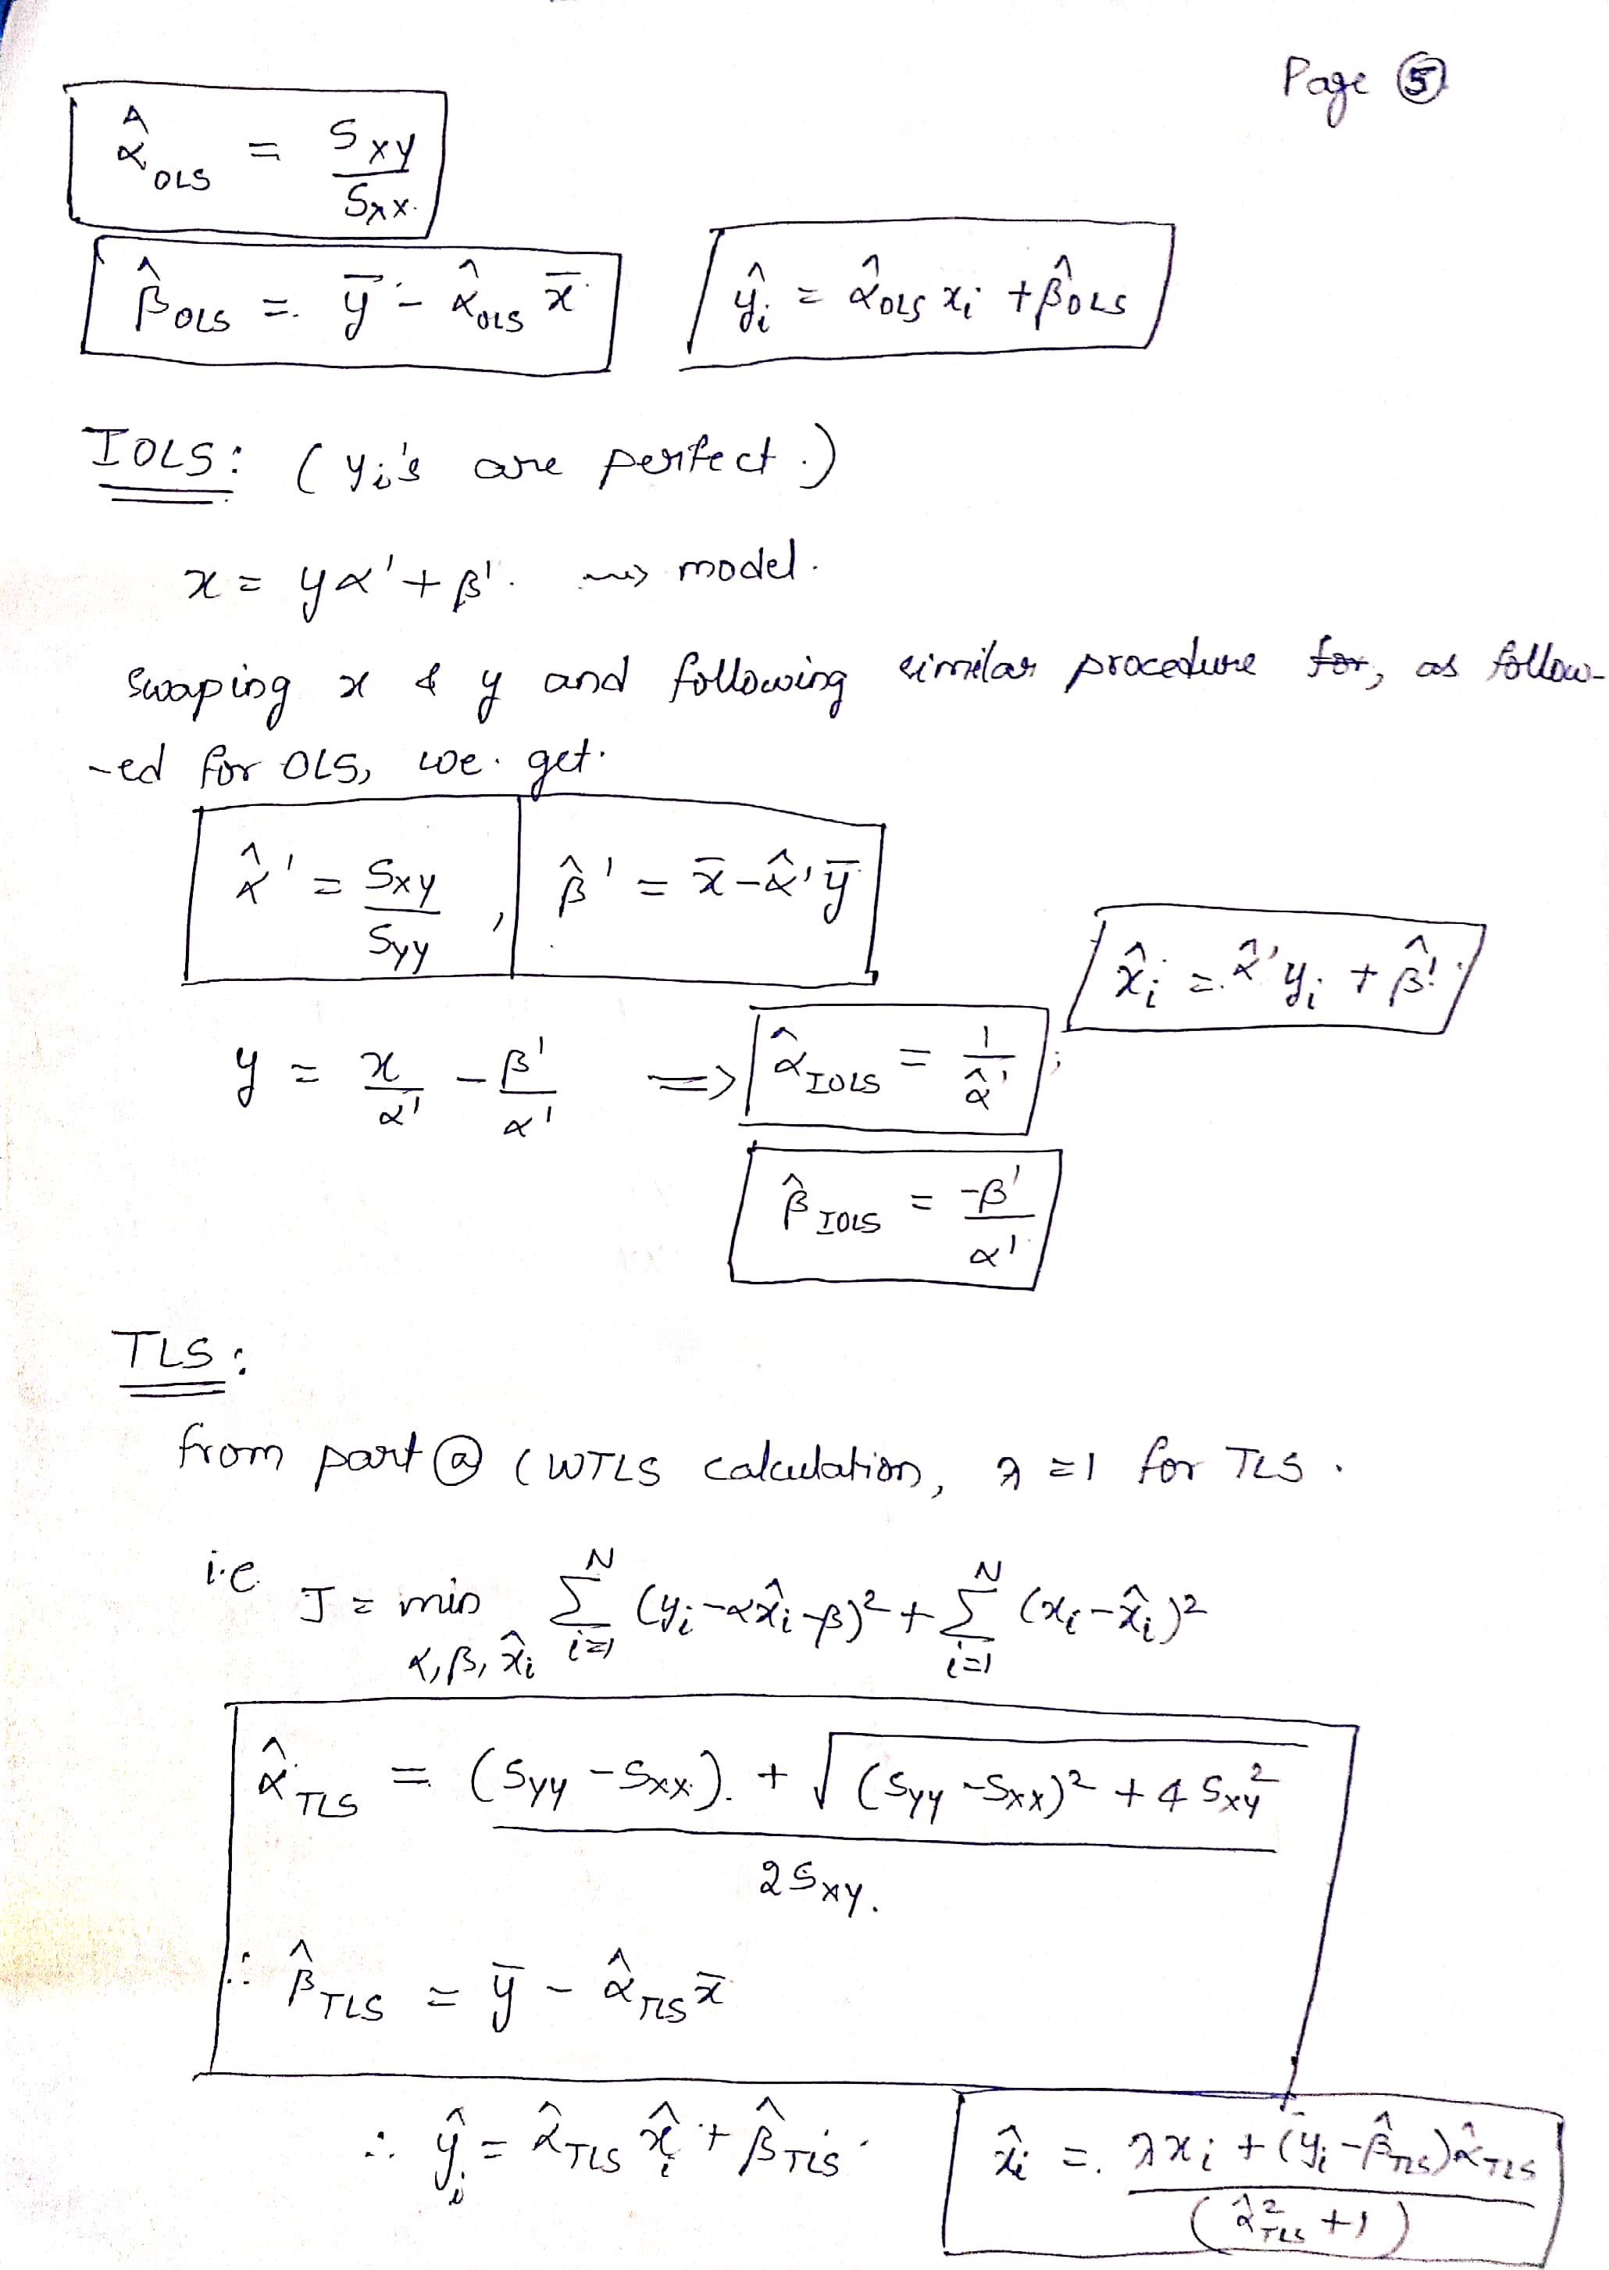

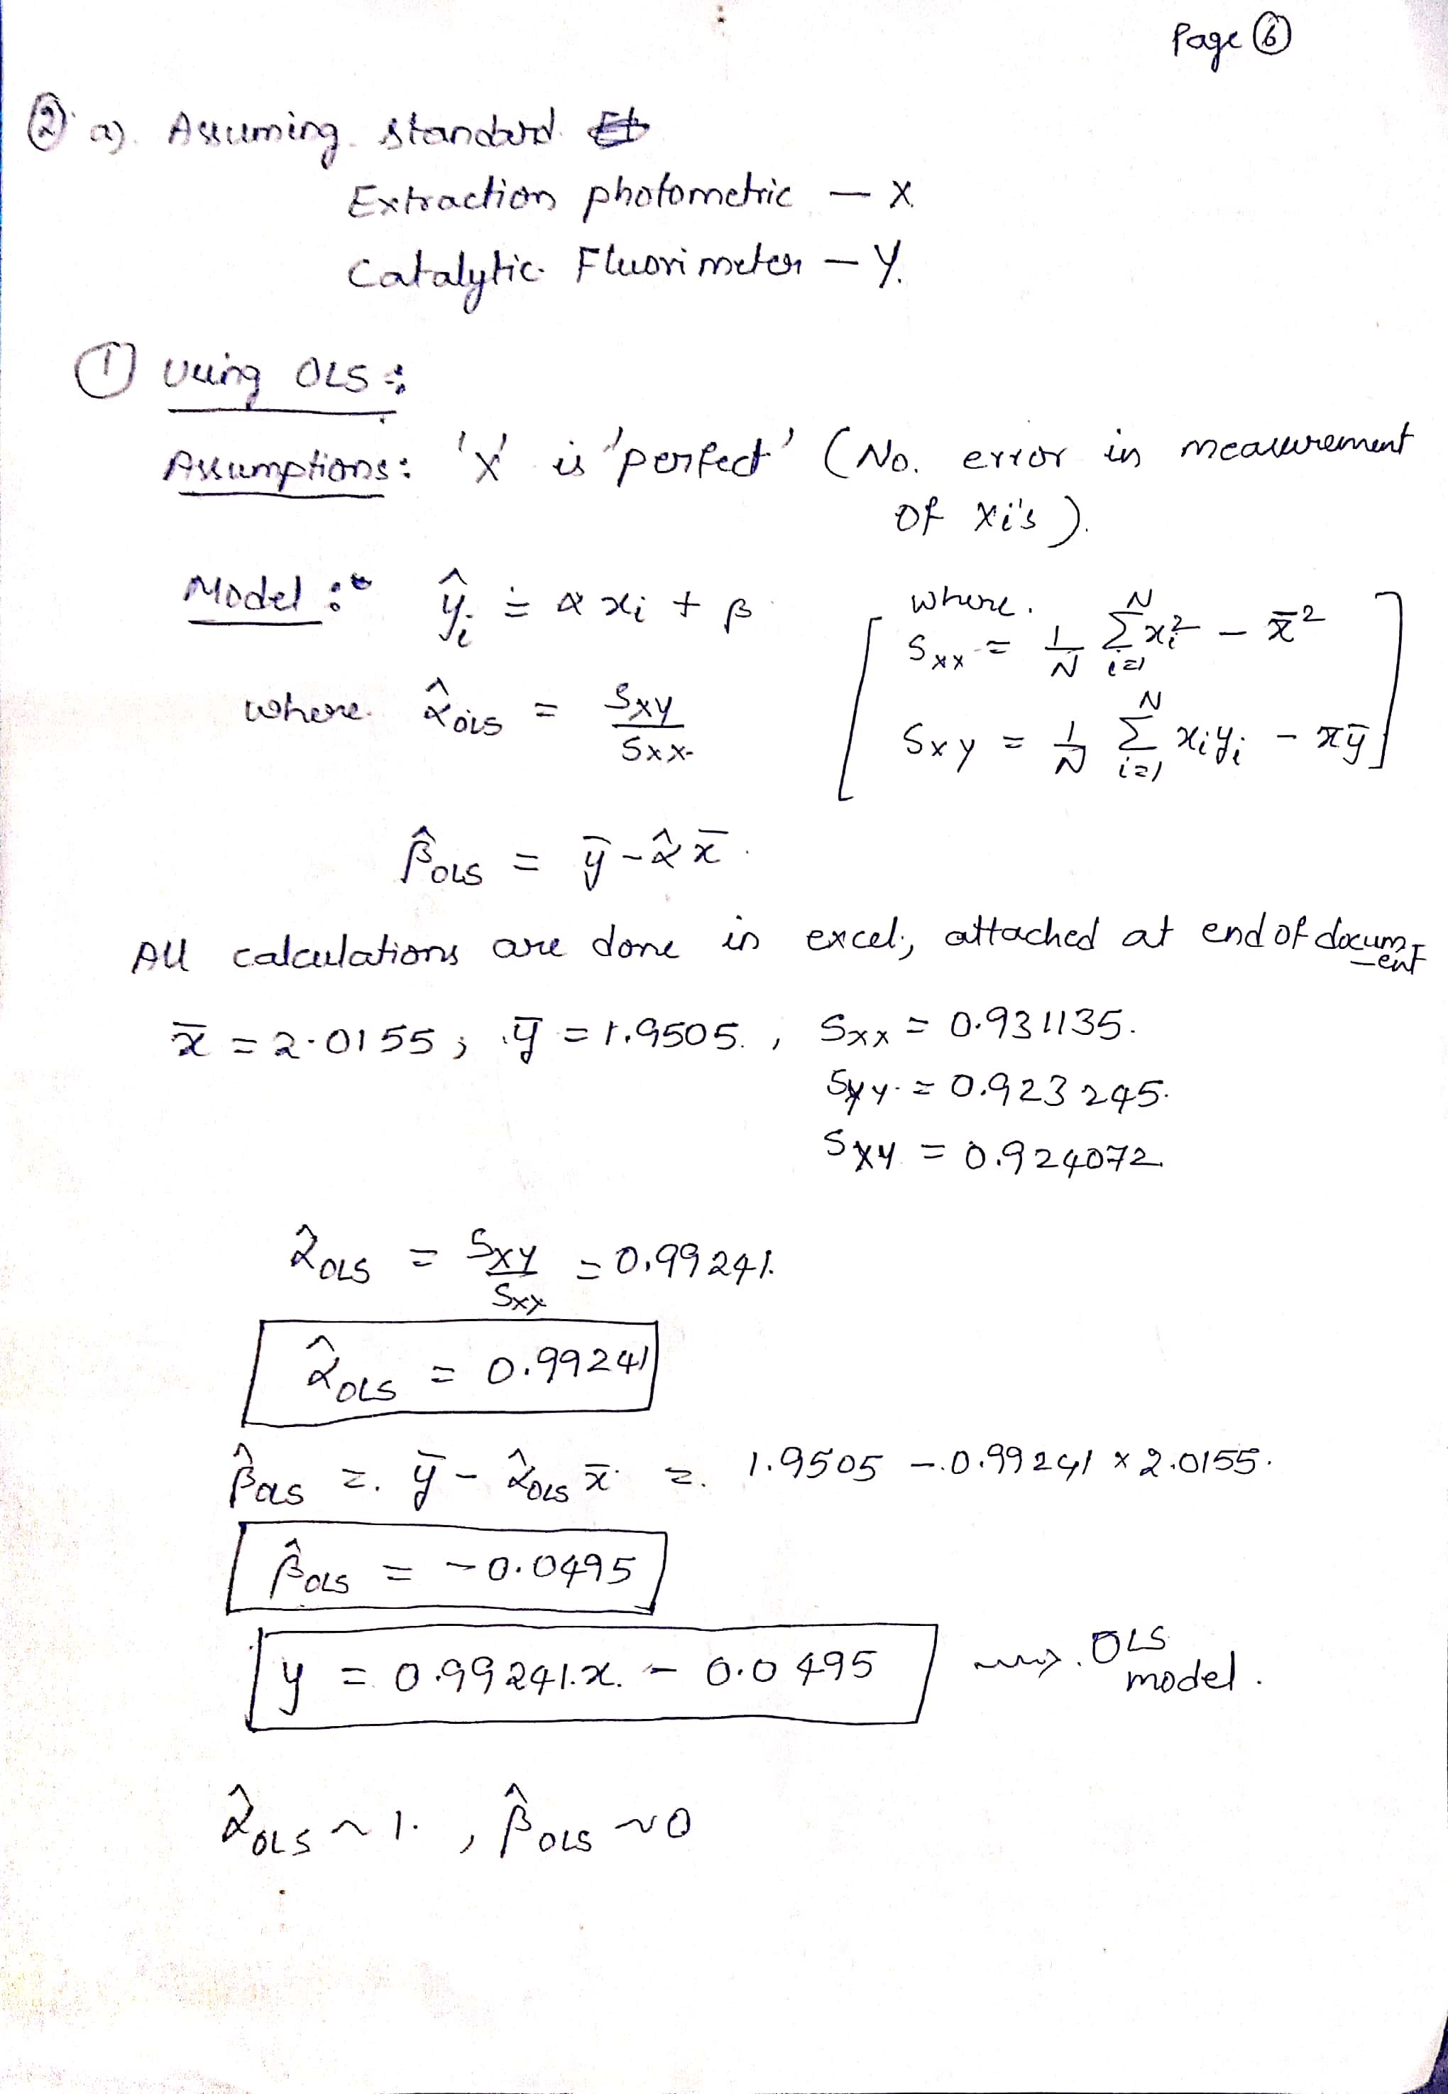

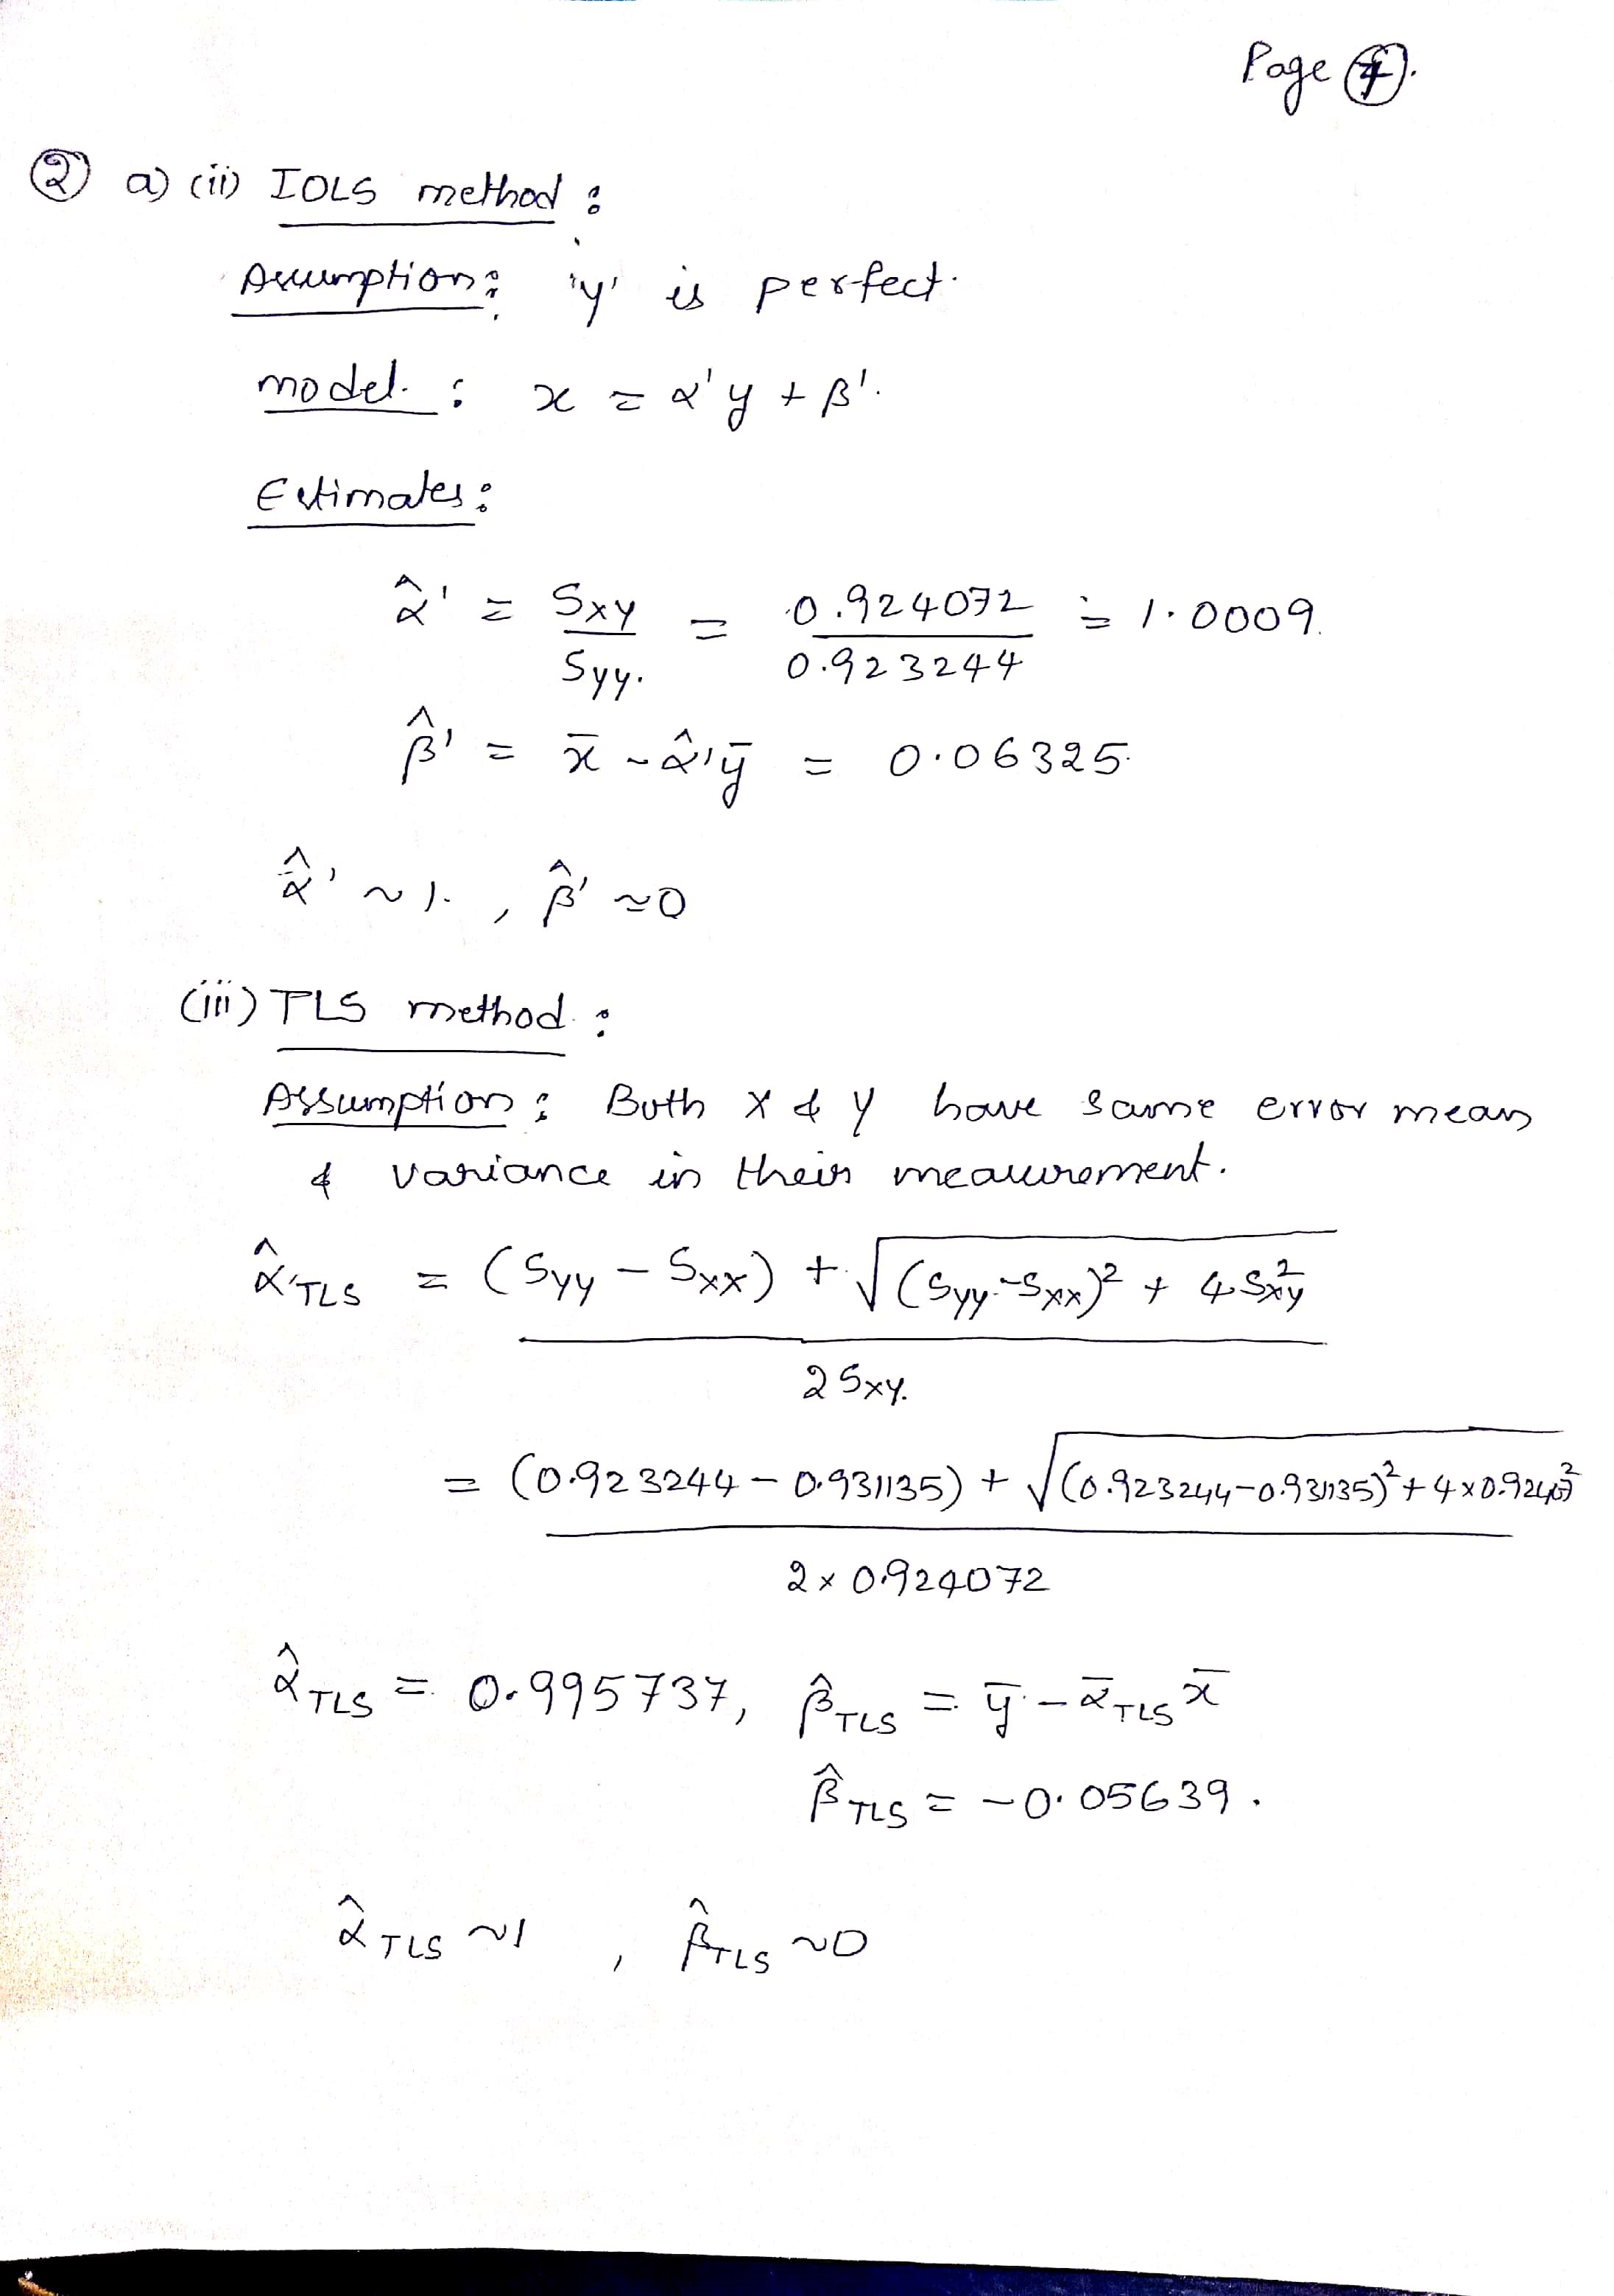

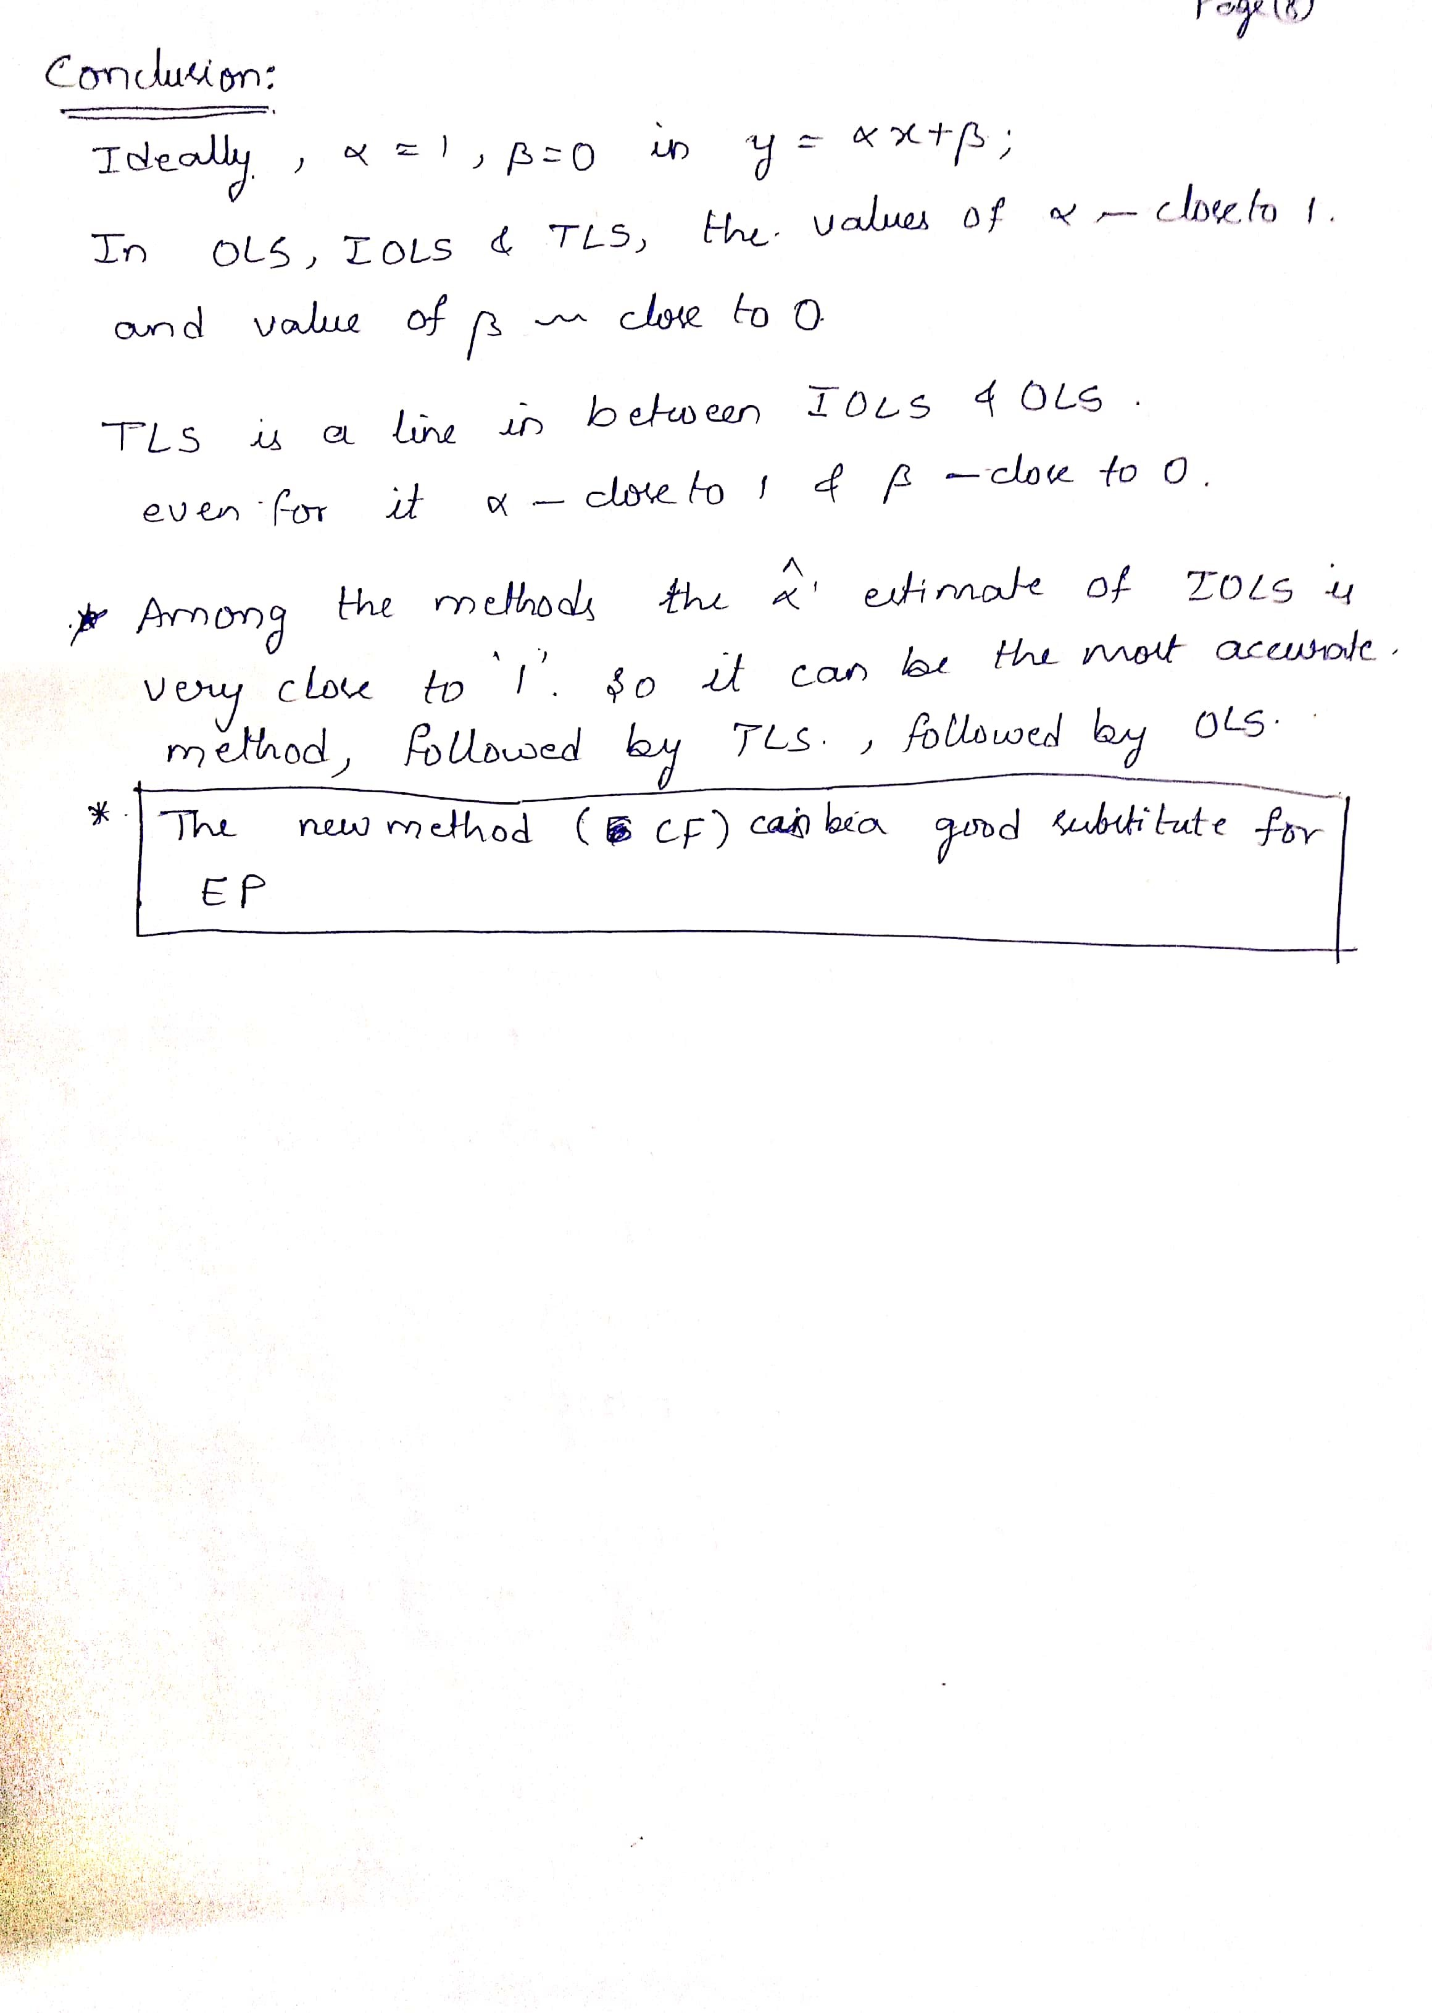

|  |  |  |  |  |  |  |
| --- | --- | --- | --- | --- | --- | --- |
| **EP_X** | **CF_y** | **Xi-X_** | **Yi-Y_** | **(Xi-X_)^2** | **(Yi-Y_)^2** | **(Xi-X_)(Yi-Y_)** |
| 1.98 | 1.87 | -0.0355 | -0.0805 | 0.00126 | 0.00648 | 0.00285775 |
| 2.31 | 2.2 | 0.2945 | 0.2495 | 0.08673 | 0.06225 | 0.07347775 |
| 3.29 | 3.15 | 1.2745 | 1.1995 | 1.62435 | 1.4388 | 1.52876275 |
| 3.56 | 3.42 | 1.5445 | 1.4695 | 2.38548 | 2.15943 | 2.26964275 |
| 1.23 | 1.1 | -0.7855 | -0.8505 | 0.61701 | 0.72335 | 0.66806775 |
| 1.57 | 1.41 | -0.4455 | -0.5405 | 0.19847 | 0.29214 | 0.24079275 |
| 2.05 | 1.84 | 0.0345 | -0.1105 | 0.00119 | 0.01221 | -0.00381225 |
| 0.66 | 0.68 | -1.3555 | -1.2705 | 1.83738 | 1.61417 | 1.72216275 |
| 0.31 | 0.27 | -1.7055 | -1.6805 | 2.90873 | 2.82408 | 2.86609275 |
| 2.82 | 2.8 | 0.8045 | 0.8495 | 0.64722 | 0.72165 | 0.68342275 |
| 0.13 | 0.14 | -1.8855 | -1.8105 | 3.55511 | 3.27791 | 3.41369775 |
| 3.15 | 3.2 | 1.1345 | 1.2495 | 1.28709 | 1.56125 | 1.41755775 |
| 2.72 | 2.7 | 0.7045 | 0.7495 | 0.49632 | 0.56175 | 0.52802275 |
| 2.31 | 2.43 | 0.2945 | 0.4795 | 0.08673 | 0.22992 | 0.14121275 |
| 1.92 | 1.78 | -0.0955 | -0.1705 | 0.00912 | 0.02907 | 0.01628275 |
| 1.56 | 1.53 | -0.4555 | -0.4205 | 0.20748 | 0.17682 | 0.19153775 |
| 0.94 | 0.84 | -1.0755 | -1.1105 | 1.1567 | 1.23321 | 1.19434275 |
| 2.27 | 2.21 | 0.2545 | 0.2595 | 0.06477 | 0.06734 | 0.06604275 |
| 3.17 | 3.1 | 1.1545 | 1.1495 | 1.33287 | 1.32135 | 1.32709775 |
| 2.36 | 2.34 | 0.3445 | 0.3895 | 0.11868 | 0.15171 | 0.13418275 |

|  |  |  |  |  |  |  |  |  |  |  |  |  |  |
| --- | --- | --- | --- | --- | --- | --- | --- | --- | --- | --- | --- | --- | --- |
| |  |  |  |  |  |  | | --- | --- | --- | --- | --- | --- | | E(X) | E(Y) |  | SXX | SYY | SXY | | 2.0155 | 1.9505 |  | 0.931135 | 0.923245 | 0.924072 | |  |
|  |  |

